**Lab 3 2 %**

**Due October 12, 2017 midnight via Blearn**

# Using ORACLE server 12c SQL*Developer (client)

Use your Oracle USER ID on BTACS database.

**Introduction**

**Oracle supports two main types of built-in functions:**

1. Single-row functions ( character functions, numeric functions, conversion functions, date functions, regular expressions functions)
2. Aggregate functions (**MIN, MAX, SUM, AVG, COUNT**, MEDIAN, STDDEV, VARIANCE .. and some more statistical functions)

Note: MIN, MAX, COUNT can be used with numbers, strings, and datetimes. The other functions are used with numbers. NULL values are ignored. DISTINCT keyword operates on distinct values.

We will use the Oracle 11g book’s script for the JustLee books company (see Lab 2). The following is the database model.

Materials:

* Database Systems text book **Chapter 6 on ISO SQL** (note the differences between ISO SQL and Oracle SQL)
* **Aggregate functions** and **GROUP BY… HAVING** clause are covered in Chapter 11 (Oracle 11g SQL book) *** skip GROUPING SETS , CUBE, ROLLUP.

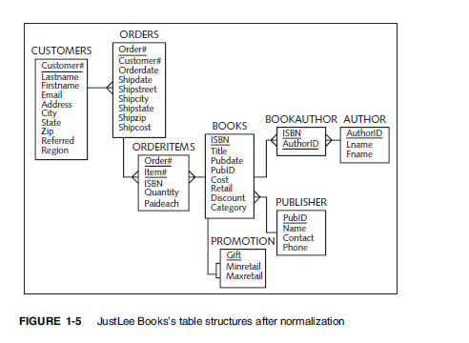

**In-class exercise**

* Count the number of orders with shipping state Washington (WA).
* Count the total number of orders waiting for the shipment (NULL as shipping date).
* List each shipping state and the total number of orders in each state. GROUP BY….
* How many different states are listed in the orders table? DISTINCT

**Individual work**

1. Calculate the total revenue from all ordered books. Note: ORDERITEMS table holds data about each Order Item (book ISBN), quantity, and the price paid for each book.
2. What is the average retail price (from BOOKS table) for the “computer” (category) books?
3. List all book categories from the books table. For each category list min, max, and average price (cost column in BOOKS).
4. List the publishing years (from BOOKS) and the number of books published in each year.
5. How many different books have not been ordered?
6. How many books (in total) authored by Jones Janice have been ordered?
7. List the customers (customer id, last name, first name) and their total number of orders (include only customers who have at least one order).
8. List the customer (customer id, last name, first name) and their total number of orders (list all customers even if they do not have orders).
9. List the customers (customer id, last name, first name) who have more than 1 order.
10. List the customers (customer id, last name, first name) who have ordered at least one “computer” book.

**Lab Submission**

Please answer questions **1-10**. Please submit pdf file with the SQL statements and the results (copy/paste/snip) from the SQLDeveloper.